**Program 1.**

**Program Name:** Sum the elements of a 2 dimensional array

**Program Purpose:** Using multiple-subscripted (2 dimensional) array with nested loop

**Problem Statement:** Write a program which declares a 2D array of size 3x3. The values of the array are input by the user at run-time (see sample output). After inputting the array values, show the sum of all the elements in the array.

**Sample Output:**

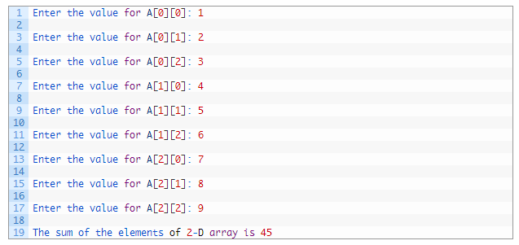

**Program 1.**

**Program Name:** add matrices

**Program Name:** multiply matrices